SAC 1Unit 2 – Tourism

Design a holiday
This SAC will be given to you on Friday 20th August. You will have time at home to do some research and collate information. It will be due on Friday 3rd September.

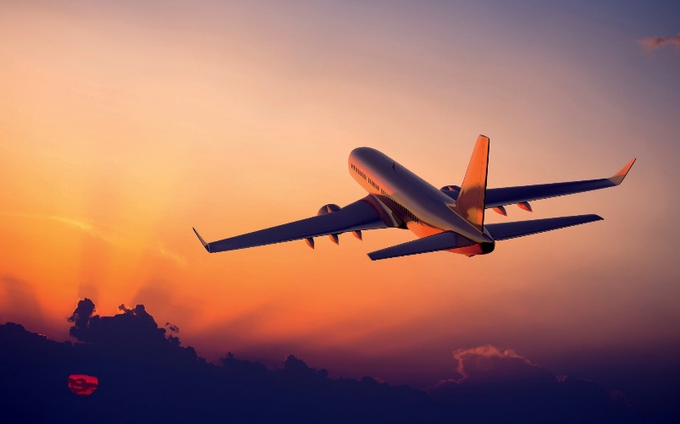

Your task is to plan and create your own travel itinerary. This SAC is designed to help develop a deeper understanding of the characteristics of tourism across the world. It will also provide you with practical skills to help plan your own overseas trip.

Please complete every page of the booklet. This SAC requires a high level of dedication to complete it well, use your class time wisely! I suggest you fill in your bibliography as you go.

Enjoy, be adventurous!

Congratulations!
In order to get the tourism industry back on its feet after the impacts of 2020, a local travel agent are handing out incentives to encourage people to begin traveling again. You have a budget of $5,000 dollars to spend over 12 days in January next year. You are free to choose a country in the world that you wish to explore. Your task is to plan, create a travel itinerary and justify your choices for each part of the trip.
- You will be an international tourist. Please provide a definition for an international tourist.
________________________________________________________________________________________________________________________________________________________________________________________________________________________________________________________________________________

Destination Unknown
You may now choose where you want to travel. Please choose one country, be adventurous, there is a lot you can do in 12 days.
- Where have you decided to go and why have you chosen this country?
________________________________________________________________________________________________________________________________________________________________________________________________________________________________________________________________________________
- Describe the location of the country, including its absolute (of the capital city) and relative location to Melbourne.
_______________________________________________________________________________________________________________________________________________________________________________________________________________________________________________________________________________________________________________________________________
Booking flights
It is time to book a flight. Search on the internet for the cheapest flight you can find to your chosen destination. The twelve days must be within the month of January next year. (Webjet.com.au)
- Destination of flight: ________________________________
- Chosen airways: ___________________________________
- Departure Date and Time from Melbourne:______________
_________________________________________________
- What time will you have to be at the airport to check in?
_________________________________________________
- What is the length of the flight (be careful of changes in time zones)? ______________________________________
- Will you stop over in another airport along the way? If so, how long for? _____________________________________
- Flight Number: ____________________________________
- Date and time of return flight to Melbourne:
__________________________________________________________________________________________________
- Return Flight Number:______________________________
- Total cost of return airfares : ____________________
Insure your travels
Now you have booked your flights you will be required to get comprehensive travel insurance. Do some searching on the internet to find a suitable company.
- What insurance company have you decided to get insurance with?
____________________________________________________________
- What does a comprehensive insurance package include?
________________________________________________________________________________________________________________________________________________________________________________________________________________________________________________
- How much is the travel insurance for your 12 day trip?
___________________________________________________________
- Would you personally buy comprehensive travel insurance for your next holiday? Why or why not?
_________________________________________________________________________________________________________________________________________________________________________________
Visas and Immunisation
Some countries require Australian citizens to obtain a Visa before entering their country.
- As an Australian citizen, do you need to obtain a Visa before entering any of your destination countries? Yes or No? If yes, how much will it cost, how long will it last and do you have to obtain it before arrival in the airport?
__________________________________________________________________________________________________________________________________________________________________________________
Some countries also require or recommend you to have certain, current immunisations. https://www.health.gov.au/health-topics/immunisation/immunisation-throughout-life/immunisation-for-travel
can be a good website to start with.
- Are there any vaccines you need before you travel overseas?
_____________________________________________________________________________________________________________________________________________________________________________________________________________________________________________

Be a tourist
Throughout the 12 days in your chosen country; you will be required to visit a place of natural beauty, a place of cultural heritage and also a dark tourist site. Use your textbook for support.
Start by choosing an interesting or beautiful natural environment you wish to visit.
- Name your chosen natural environment tourist site, explain why it is a popular tourist destination and discern how you will travel there (from city centre or airport).
__________________________________________________________________________________________________________________________________________________________________________________________________________________________________________________________________________________________________________________________________________Attach either a printed, referenced photo of your chosen destination or carefully draw a picture.
Now pick a cultural tourist site – this might include a World Heritage site, a place where a film was set, a famous food or shopping region, a popular sports complex or a religious destination.
- Name your chosen cultural tourist site, provide a map to show its location, explain how you will travel there and state why you would like to visit it.
______________________________________________________________________________________________________________________________________________________________________________________________________________________________________________________________________________________________________________________________________________________________________________________________________________________________________________________________________________________________________________________________________________________________________
Print and attach or draw map (please include correct scale and title)
Thirdly, choose a dark tourism site.
- Name and describe your chosen dark tourism site, explain how you will travel there.
________________________________________________________________________________________________________________________________________________________________________________________________________________________________________________________________________________________________________________________________________________________________________________________________________________________________________________________
- Give two reasons why tourists would want to visit a dark tourist site.
________________________________________________________________________________________________________________________________________________________________________________________________________________________________________________________________________________
- Identify and justify the stage of Butler’s Model of Tourism Development for your country and make a prediction of where it might be by 2030.
_____________________________________________________________________________________________________________________________________________________________________________________________________________________________________________________________________________________________________________________________________________________________________________________________________________________________________________________
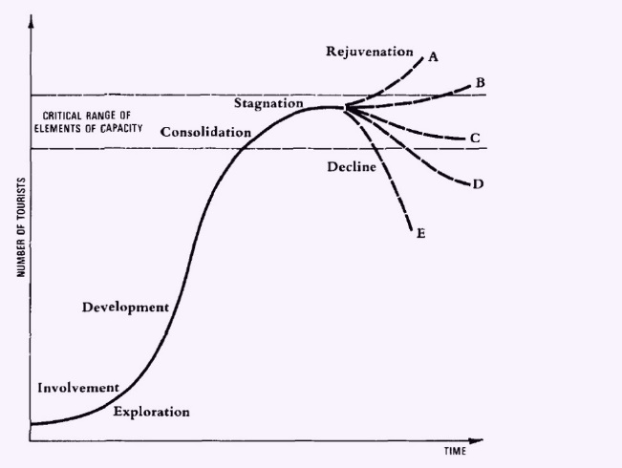
Accommodation
As part of the package, you must ‘pre-book’ all of your accommodation for the eleven nights while you are overseas. This will also make travelling less stressful as you will know where you’ll be sleeping every night.
Find three different accommodation possibilities for your travels over the 10 days. Try to explore a variety of accommodation options; maybe a resort, backpacker hostel, a hotel or an air B&B.

- The name of the first accommodation option and find how much it would cost for one adult for one night.
__________________________________________________________________________________________________________________________________________________________________

- The name of the second accommodation option and find how much it would cost for one adult for one night.
__________________________________________________________________________________________________________________________________________________________________

- The name of the third accommodation option and find how much it would cost for one adult for one night.
__________________________________________________________________________________________________________________________________________________________________
- If you stayed in one option for 3 nights and 4 nights for the other two options. How much would the total cost for accommodation be?
___________________________________________________________________________________________________________

- If you add together the costs of your flights, your insurance and the total cost of your accommodation, how much of your budget have you used so far? How much money do you have left over to spend on food and other daily expenses?
___________________________________________________________________________________________________________

Climate
- Please create a climograph for the city/destination you fly into. Include the average temperature and rainfall for each month of the year. Please ensure the graph is well labelled and has a title.

- By using the climate information predict the seasonal tourist trends for your destination. _____________________________________________________________________________________________________________________________________________________________________________________________________________________________________________________________________________________________________________________
Research a marketing campaign for your chosen destination. State below if it’s a video or an article.
- Do you think it is a successful campaign that would make people want to visit? Please justify why or why not.
______________________________________________________________________________________________________________________________________________________________________________________________________________________________________________________________________________________________________________________________________
The sustainability of tourism
Finally, it will be useful to predict the potential impacts of tourism on your chosen destination. Pick one of the tourist sites or cities you are going to and predict a potential impact of tourism and a potential management strategy.
- Predict what one environmental tourist impact might be and a relevant management strategy.
________________________________________________________________________________________________________________________________________________________________________________________________________________________________________________________________________________________________________________________
- Predict what one economic tourist impact might be and a relevant management strategy.
________________________________________________________________________________________________________________________________________________________________________________________________________________________________________________________________________________________________________________________
- Predict what one cultural-social tourist impact might be and a relevant management strategy.
________________________________________________________________________________________________________________________________________________________________________________________________________________________________________________________________________________________________________________________ __________________________________________________

