Main Lesson: Prohibition
Day 7 – Rise of Organised Crime during Prohibition
The term “organized crime” didn’t really exist in the United States before Prohibition. Criminal gangs had run amok in American cities since the late 19th-century, but they were mostly bands of street thugs running small-time extortion and loansharking rackets in predominantly ethnic Italian, Jewish, Irish and Polish neighbourhoods.
In fact, before the passing of the 18th Amendment, it wasn’t the mobsters who ran the most organized criminal schemes in America, but corrupt political bosses, whose thugs would intimidate opposition candidates and funnel votes to the boss. In return, the politicians and police chiefs would turn a blind eye to illegal gambling and prostitution rings.
But the underworld power dynamics shifted dramatically with the onset of Prohibition. The key to running a successful bootlegging operation was a paramilitary organisation, something that the average citizen would not have had access to. At first, the street gangs didn’t know anything about business, but they knew how to handle a gun and how to intimidate the competition. They could protect illegal breweries and rum-running operations from rival gangs, provide security for speakeasies and pay off any nosey cops or politicians to look the other way.
It wasn’t long before the mobsters were raking in absurd amounts of money and it was politicians and cops who were taking the orders. As the money kept pouring it, these formerly small-time street thugs had to become businessmen. They had to hire lawyers and accountants to launder the millions in ill-gotten cash piling up each month. They had to start thinking about strategic partnerships with other gangs and shipping logistics and real estate investment.
In the 1920s, Charles “Lucky” Luciano was famous for bringing together some of New York’s biggest Italian and Jewish mobsters to dominate the city’s bootlegging business. In Chicago, Johnny Torrio kept a fragile peace between his Italian-run bootlegging operation in the city’s South Side and the Irish and Polish gangs working the North Side. But it didn’t last. By the time Torrio’s successor Al Capone took over, it was an all-out turf war. In the infamous St. Valentine’s Day Massacre of 1929, Capone’s men dressed as police officers and gunned down seven of the rival gang’s henchmen.
The demand for illegal beer, wine and liquor was so great during the Prohibition that mob kingpins like Capone were pulling in as much as $100 million a year in the mid-1920s ($1.4 billion in today’s value) and spending a half million dollars a month in bribes to police, politicians and federal investigators.
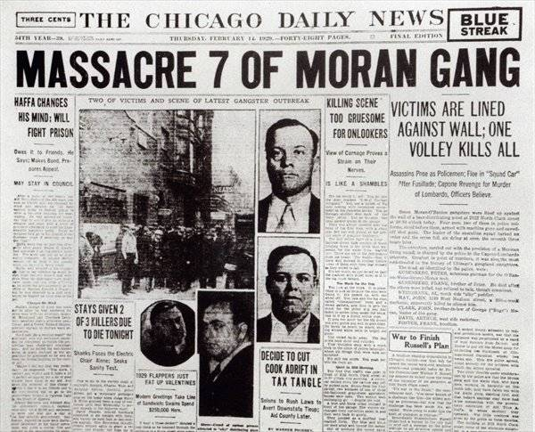
When Prohibition was finally repealed in 1933, the biggest gangs shifted their operations away from alcohol and into secondary businesses like drugs, gambling and prostitution. In hindsight, it’s clear that Prohibition, a national temperance campaign aimed at reforming America's worst tendencies, gave birth to one of the nation’s worst criminal traditions.
